xDesign Document Development Standards

- Proper document analysis should be done – identify the common components, common text among the forms, logical breaks
- Within a document, fewer the rules, more easier to maintain and more efficient to process
- Avoid section rules without criteria, in case needed, we should group more than 3 content rules
- Use criteria at section level in order to skip the processing within the section if criteria fails
- Minimize the content rules, combine generic content for all attributes
- Order content groups by most commonly used at the top so that unnecessary evaluation of content items can be avoided
- Proper read loop
Read and read next should refer to same table
Entry and exit (GOTO) criteria should have EOF check for the respective table
If nested loops, ensure child table is looped first before the parent table
- Use a Table rule rather than a read loop wherever possible –
1 table rule = 1 label rule+1 content rule+ 1 read next rule + 1 goto rule
- Don’t repeat the same criteria within a section – leads to additional processing
- Do not check attribute values (such as Jurisdiction and Effective date) in criteria - leads to additional processing
- Create smaller documents, possibly one document for one Line of Business
- Good data design improves performance
Fewer tables in xml
Minimize user variables - use xml variables instead of user variables, in such case, better move the calculations to data part rather than bring into xPression.
xDesign Document Naming Conventions Standards

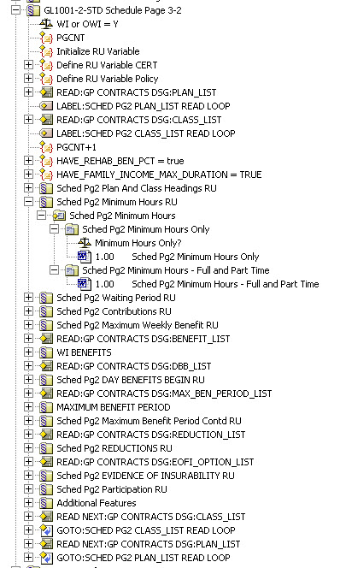
Major sections – These should match the form name contained in the section. This example is for the STD GL1001-2-STD Schedule detail pages.

Variable Names – In the spec documents some variables are used to control text or used in criteria. If these variables are needed in the xPression code, use those names. Else come up with meaningful names yourself.
Misc variable name
Variable used in spec document

Minor Section Names – These names should be as descriptive as possible. The “RU” at the end of the name denotes the use of Revision Units in that section.

Criteria – Criteria names should reflect what is being verified if possible. We have found this is helpful during debugging in Preview.

Content Items – Content items should be named as descriptive as possible. This also aids in debugging.

Label Names – These must be unique names and should be descriptive. But we have found if the name is too long it’s hard to locate in the drop down box on the GOTO wizard.

Additional Minor Section Names – In these samples the section names refer to supporting documents to the main spec document. It can be all caps to indicate that particular Section.

